Kali Charan Nigam Institute
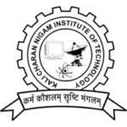
of Technology Banda

Session : 2022-23
Department of Computer Science & Engineering
A Mini Project Report File (KCS-354)
On
‘Typing Speed Test’

Bachelor of Technology
in
Computer Science & Engineering
Under the guidance
of
Mr. Pradeep Sachan

Submitted to Submitted by
Mr. Jitendra Nishad Pranjal Chakravarti
2101390100052

